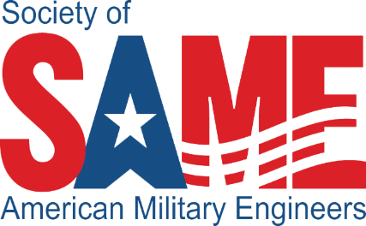
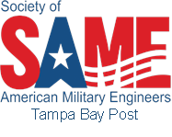
9th Annual Joint Training and
Education Day (JTED)
February 26, 2025
4th Annual Joint Training and
Education Day (JTED)
February 28, 2018

March 1, 2017
Tampa Bay Post
Tampa Bay Post
Tampa Bay Post
Tampa Bay Post
Agenda
Centre Club, 123 S West Shore Blvd 8th Floor
Tampa, Florida
1000 – 1030 Registration / Networking
1030 – 1045 Opening Comments / Sponsor Thanks
1045 – 1145 Panel Discussion: Federal Agency Small Business Opportunities (USACE Mobile & Savannah, NAVFAC SE)
1145 – 1315 Lunch / Keynote Speaker: COL Sebastien P. Joly, Commander, U.S. Army Corps of Engineers Engineering and Support Center, Huntsville
1315 – 1330 Break and Networking
1330 – 1430 Panel Discussion: Veteran and Trades Development For Federal Construction
1430 – 1445 Break and Networking
1445 – 1545 Panel Discussion: Emergency Management Response Contracting Opportunities
1545 – 1700 Final Comments and Networking
SOCIAL – 1730

Thank you to our Sponsors:
GOLD SPONSORS


SOCIAL SPONSORS
